Commander, International Shrine Aviation Association Gone West page 1
By Deo Carter, Chaplin, ISAA

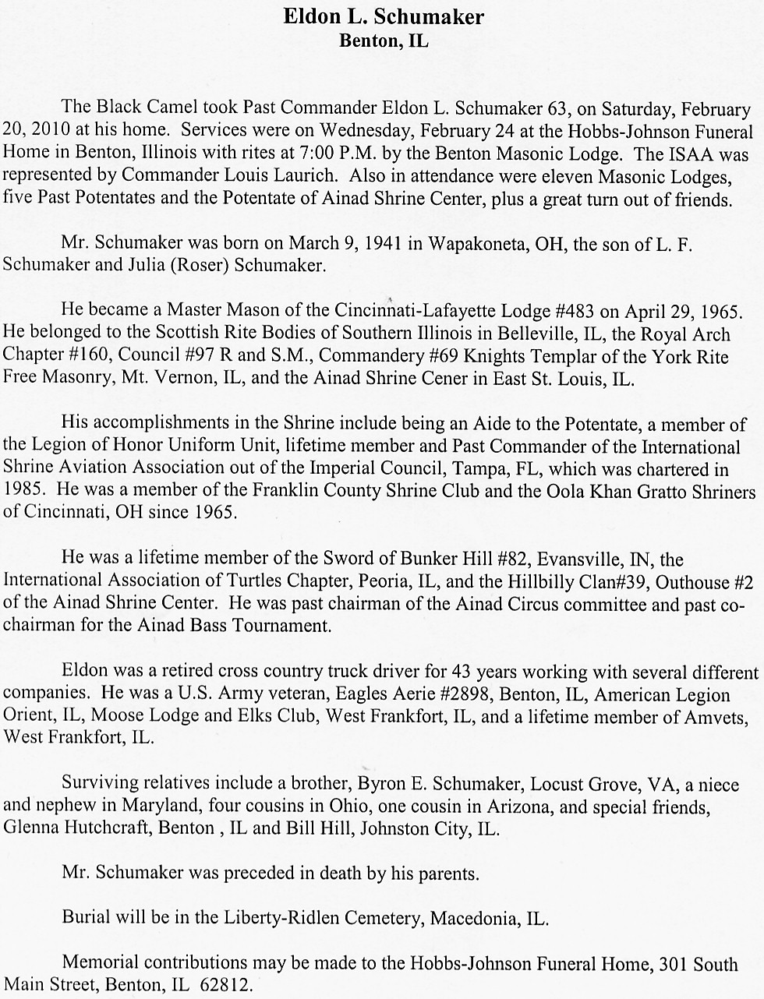

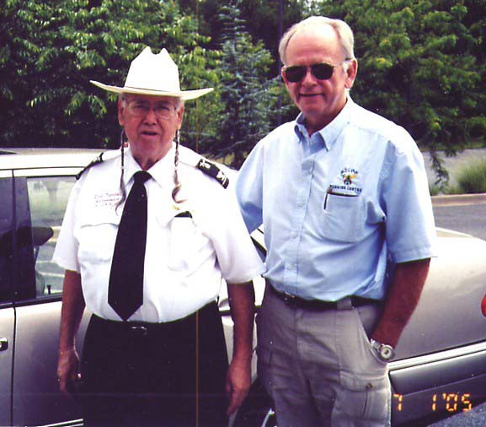April - May 2010
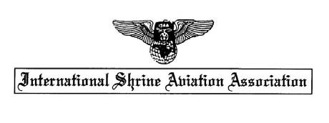

Well Nobles, what can I tell you. The March Mid Winter meeting was pretty well attended in spite of the IFR weather that kept some airplanes home. Even some of the airlines were delayed by the weather. But here's what happened in case you missed it.

Don Tyndall was appointed and voted on as the ISAA 4th Vice Commander. Noble Don is from Muskogee, Oklahoma. A real Okie from Muskogee. Don was in the service in
Viet Nam and if I ever get a picture I'll put it in the newsletter. Don had 2 sons, Don Jr was a Navy Seal and was killed in the Gulf War. His other son William also was in the Navy and now lives in Dallas Texas.

Noble Tyndall has been married 3 times and is now thinking of a 4th. His lady friend is Marla and she looks after him. Don got delayed at the airport and didn't make it to
the meeting. We all are sorry we missed him.

4Th Vice Cmdr Tyndall, Muskogee, Ok Noble Bob Duffield, London, Ont, Ca
Bob is a Canadian Ambassador.
Page 2

Ed Malinowski has been appointed an ambassador. Noble Ed lives in Burbank, Ill and works for the NTSB. It's a good idea to have friends in high places. Noble Ed was in the service stationed near Iraq. He can be reached at 708 576 8571.

ISAA has a new Banner. Noble Deo Carter had one made and presented it at the meeting. Everyone chipped in toward the cost.

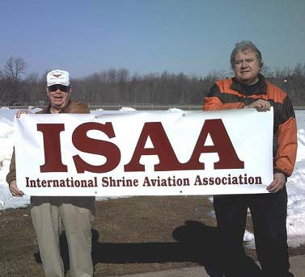
Commander Lou Laurich, Tadmor, Akron
Ambassador Ray (Bud) Goodman Al Koran Shrine, Cleveland, Oh

The Program for the Mid Winter Meeting
was presented by Mark Washam, Director of the Flight Transport Team for the Cincinnati Hospital. Mark discussed the Hospital Jet Operations, the emergency equipment used, the Personnel and the training they get.

He had a power point presentation showing how the team operates. The patients are usually already in a transport so they aren't moved individually. The pictures showed the advanced equipment used in the planes and
the team in the planes.

The smiles on the patients and their family really makes it all worthwhile to his team.
Sorry that some of you missed it.

Here is an Honor close to home for ISAA. Frances and John have helped ISAA in so many ways over the years. We do appreciate their hard work and support.
Tarum Court #14, LOS have installed
Frances' mom, Lady Ruby Warmouth as High Priestess for 2010 2011. It was my pleasure to meet her in Indianapolis last year.
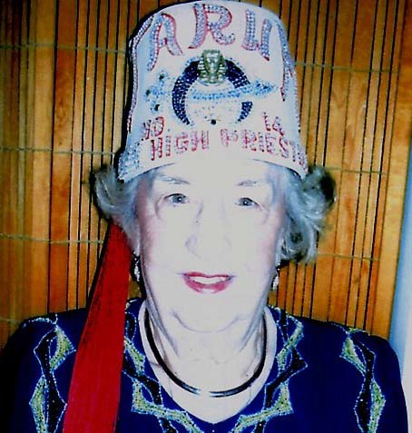
Congratulations Lady Ruby. Special Service Award
A Service Award Certificate has been made
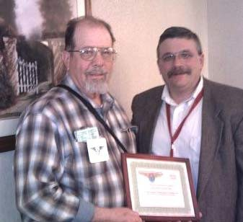to honor the Nobles who flew children to Shrine Hospitals and other hospitals. Trying to put together this info is quite a challenge. Send names to lou_alumcast@hotmail.com
Page 3 George Odell, our first Commander
1985, has flown easily over 100 flights and
was presented the first Certificate at the Mid Winter meeting by Mark Washam, director, flt operations team, Cinci Shrine Hospital.

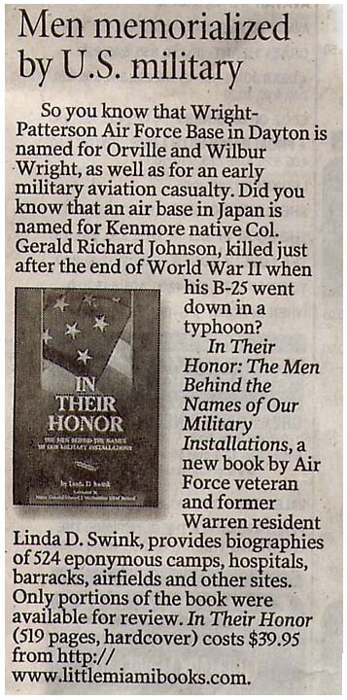

PASSPORTS, PASSPORTS, PASSPORTS
Check your passport. Is it ok for Canada?

Welcome to new members. This newsletter has been pretty busy. We don't want to forget you and your contribution to the Shrine.

Email info wanted. Send email info changes and additions to Frank Green 3rd Vice Cmdr, email c.p.b.services@sbcglobal.net

Dayton Mid Winter Pictures 2010

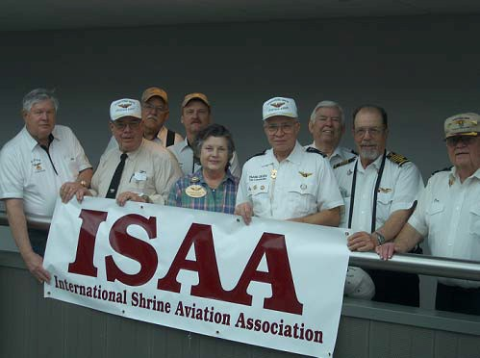
On a Stormy Cold day, ISAA members went to the Air Museum. The museum was packed with people from all over world.

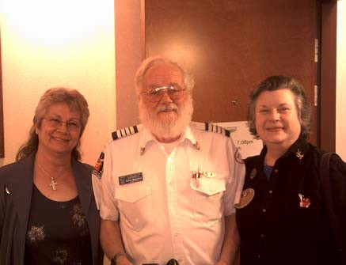Frances, John, and Shirley
Page 4

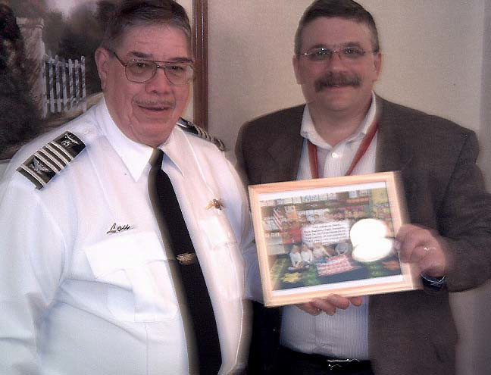
Mark Washam, Dir of Flt Operations for the Cinci Hospital presented a program about flying families and received a Thank You

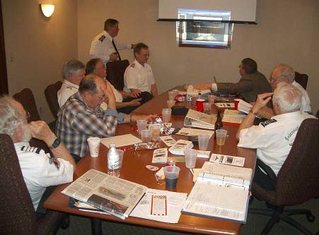
The business meeting was conducted. The coming events were discussed. More info will be in the newsletter or in emails. Don't become lost in the desert. Be up to date. -lou

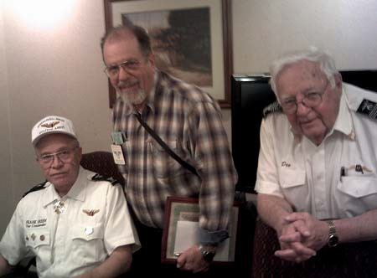Frank, George and Deo
*** Late Breaking News about Toronto *** Our hotel is the Doubletree Airport Toronto,
655 Dixon Rd, Toronto, Ont, Ca M9W1J3 Reservations 416 244 - 1711
Use rate # 85868734

Room rate 120 Can dollar + 33.60 Can dollar Arrive Fri 7 2 10 Depart Sun 7 4 10

Our Banquet will be Sat 7 3 10, 6 to 11pm at the Doubletree Hotel.

Our Bus. meeting will be Sat 7 3 10, 9 11am in the Quebec Room of the Fairmont Royal York Hotel (downtown) with the rest of the Shriners and near the Convention Center.
There will be a map in emails to come. Thanks to everyone who helped. -lou, Cmdr

