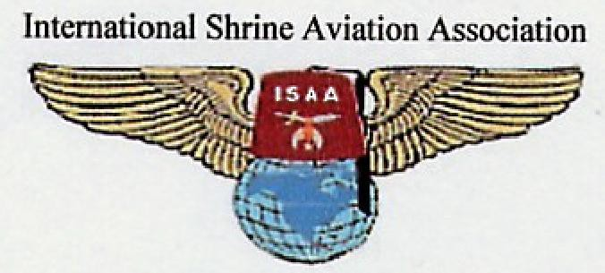

Happy 25th Anniversory to the International Shrine Aviation Association. To the Officers and Members, you
have a reason to celebrate. Below are the Officers from 25 years ago. Look at those active young guys.
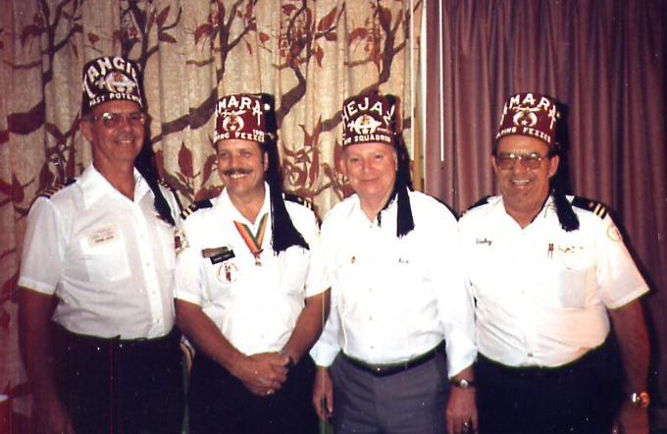
ISAA Officers who went to the Imperial Session in Atlanta in 1985. From left to right: Jerome Given, 1st Vice Cmdr; George Odell, Cmdr; Red Sanders, 2nd Vice Cmdr; Wesley Dieckman, Sec/Treas

FROM THE AMBASSADRESS’S DESK page 2
By

Lady Becky Buckner, Ambassadress

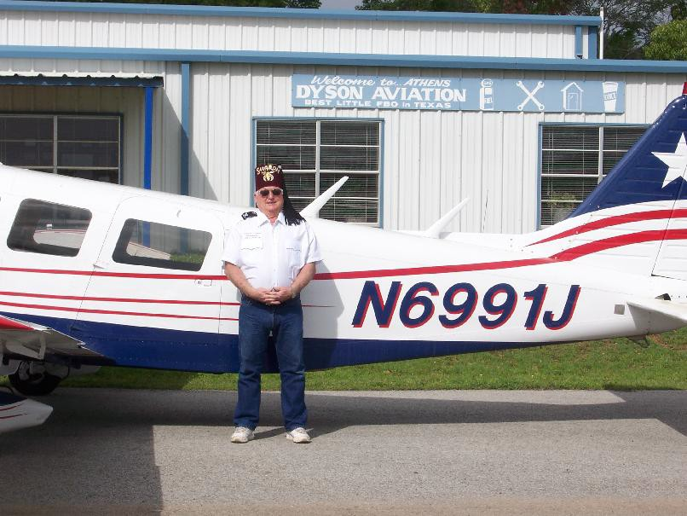

Carroll “Dad’ Dyson and his wife, Lady Candice, live in Athens, Texas where he owns and operates Dyson Aviation at the Athens airport. The airport accommodates private jets (Lear, Citation, etc.) and has provisions for airplane storage. Dyson Aviation provides fuel, aircraft repairs, aviation parking, flight instruction and other services. Carroll has the following licenses: aircraft mechanic, engines and air frames, single and multi-engines, jets, helicopters, and fixed wing. He is licensed to instruct and has his instrument rating.

Carroll has always been interested in aviation. His mother said that when he was just a couple of years old he was crazy about anything that flew. He tried to build airplanes when he was young and, of course, built models which he had on display everywhere. He started hanging around the airport when he was old enough to go by himself, about sixteen, and would do anything to get to ride in an airplane. When he had enough money or worked for the airport owner, he would take a flying lesson.

He finally got his private pilot certificate when he was nineteen. He was in College at Nacogdoches, Texas, and after College, went in the Army where he applied for and was accepted in flight school. After flight school, Carroll went to Viet Nam as a helicopter pilot. After completing his first tour in Viet Nam, he was an instructor pilot in the Army Helicopter School. He went back to Viet Nam for his second tour as a fixed wing pilot

Page 3 When Carroll was released from active duty in the late sixties, he went to work for Southern Airways. They folded in 1974, and he went to work for Petroleum Helicopters. He flew for PHI until he retired. He has been flying about fifty years and has over twenty two thousand hours.

Carroll has been a Master Mason and a Scottish Rite Mason for many years and joined the Sharon Shrine and the Flying Fez in Tyler, Texas in the late nineties. Since that time he has flown 31 trips to the Shriner’s Hospitals. Most flights were to the Galveston Burn Center and a few were to the Houston Children’s Hospital. Since the Galveston Burn Center recently reopened, a child he was scheduled to fly had to go by surface due to bad weather.

It is with great pride, my honor and privilege to share with you the flying history of this wonderful, unassuming man-----our special friend, Carroll Dyson.

----------------------------------------------------

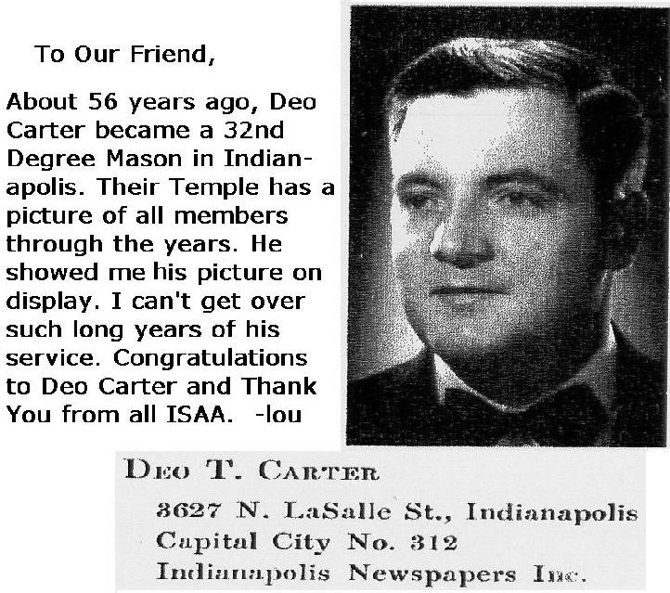

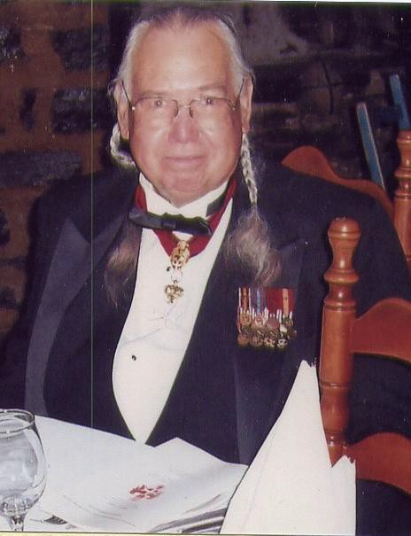The photo is of Knight Commander Don Louis Tyndall Sr. at a dinner in Canada for Knight Hospitaliers of St. John of Jerusalem. April 2010
Noble Deo Carter served as ISAA’s treasurer for the past four years. Now, that is a tough job. Your Commander has been doing it since October and it is no picnic. I realize I’m just a kid here at ISAA but I really enjoy hearing the flying stories about the old days

.

Noble Don Tyndall is our 4th Vice Commander on Muskogee, Okla. We had a ISAA meeting there and toured the Museum that had info on ‘Code Talkers’ of the WWII. Remember the Movie. There were a lot of WWII pictures.
Deo told me many years ago he landed at Fort Knox, Ky and was surrounded by some 300 soldiers. I don’t remember all the details. I guess he didn’t have any gold so they let him leave. We’ll ask him at the Toronto meeting. –lou

You need PASSPORT for Canada.

Here’s something you don’t see often.
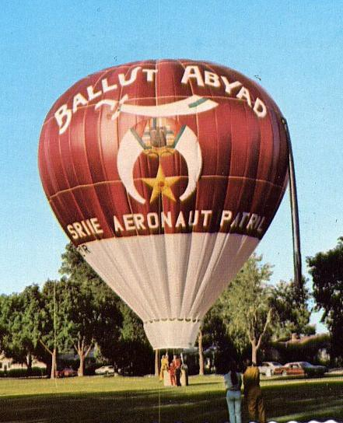

That is a Fez. See the Tassel. Great Job!!
------------------------

Toronto Info
Our hotel is the Doubletree Airport Toronto,
655 Dixon Rd, Toronto, Ont, Ca M9W1J3
Reservations 416 - 244 – 1711 Use rate # 85868734

Room rate 120 Can dollar + 33.60 Can dollar
Arrive Fri 7-2-10 Depart Sun 7-4-10

Our Banquet will be Sat 7-3-10, 6 to 11pm at the Doubletree Hotel.

Our Bus. meeting will be Sat 7-3-10, 9 - 11am in the Quebec Room of the Fairmont Royal York Hotel (downtown) with the rest of the Shriners and near the Convention Center.
DON’T FORGET PASSPORTS!!!
Page 4
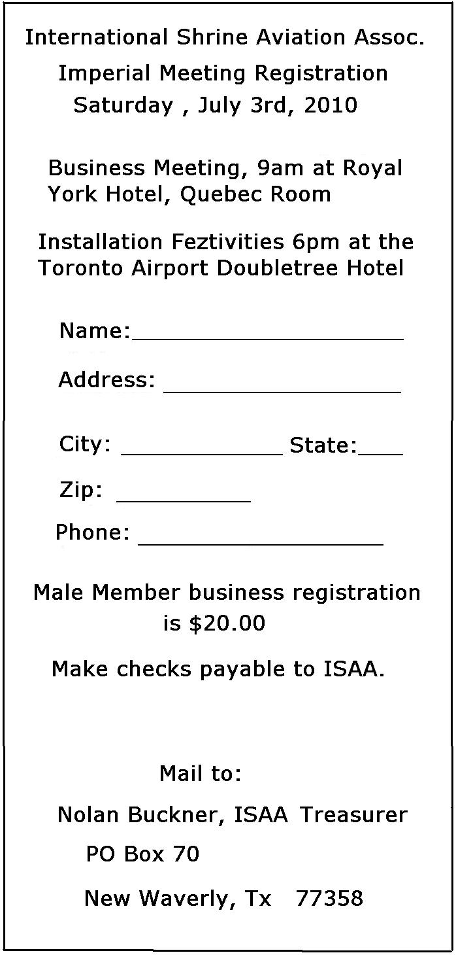

Well, that’s about it for me guys and gals. It’s been fun being Commander. It’s too bad Noble Eldon passed away. He did his best for ISAA and was a true Masonic person. To the younger Nobles, Get involved. We have 2 meetings a year. Make time and bring the wife. She can participate too. And by all means, be a good pleasant person to everyone. You are a Mason and it shows. Remember, ISAA Shriners never let a child down.
Almost a has been. –lou, Cmdr

